SQL PROJECT REPORT

Bookstore Sales & Customer Analysis using SQL
Name: Pranjal Tiwari
Database: PostgreSQL
Project Type: SQL Data Analysis Project

1. Project Overview
This project focuses on analyzing a bookstore database using SQL to extract meaningful business insights related to sales, customers, revenue, and inventory management.
The dataset was provided in Excel (CSV) format and imported into PostgreSQL. Using structured SQL queries, various real-world business questions were answered to understand customer behavior, book demand, and stock performance.

2. Dataset Description
The project uses three datasets:
Books.csv – Contains information about books, genres, prices, and stock.
Customers.csv – Contains customer details and location.
Orders.csv – Contains order details, quantities, and total amount.

- Database Schema Design

Books Table:

CREATE TABLE Books (
Book_ID SERIAL PRIMARY KEY,
Title VARCHAR(100),
Author VARCHAR(100),
Genre VARCHAR(50),
Published_year INT,
Price NUMERIC(10,2),
Stock INT
);

Customers Table:

CREATE TABLE Customers (
Customer_ID SERIAL PRIMARY KEY,
Name VARCHAR(100),
Email VARCHAR(100),
Phone VARCHAR(15),
City VARCHAR(50),
Country VARCHAR(100)
);

Orders Table:

CREATE TABLE Orders (
Order_Id SERIAL PRIMARY KEY,
Customer_Id INT REFERENCES Customers(Customer_ID),
Book_ID INT REFERENCES Books(Book_ID),
Order_Date DATE,
Quantity INT,
Total_Amount NUMERIC(10,2)
);

Queries:

Select * FROM Books ;

Select * FROM Customers;

Select * FROM Orders;

- SQL Queries & Analysis

Q1. Retrieve all books in the Fiction genre .

Answer:
SELECT * FROM Books
WHERE Genre = 'Fiction';
Output:

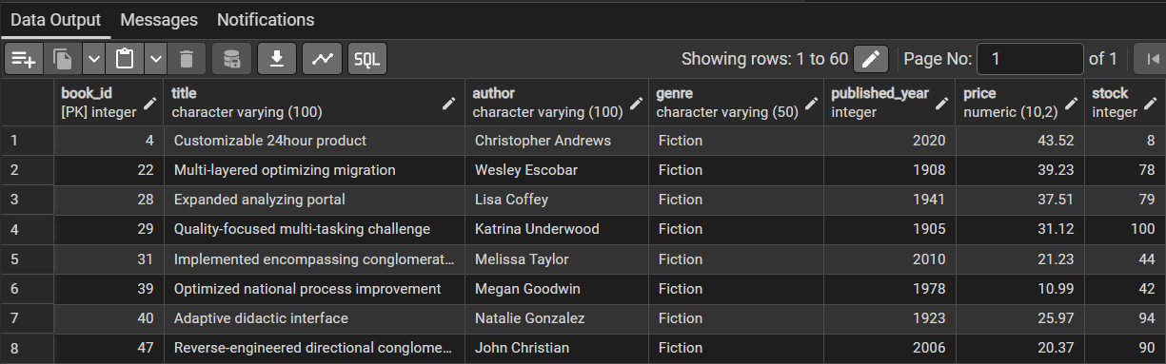

Q2. Find books published after 1950 .

Answer:
SELECT * FROM Books
WHERE Published_year > 1950;
Output:

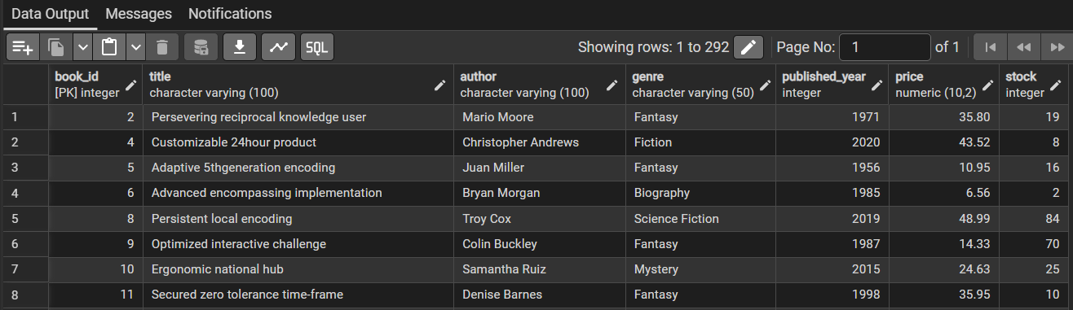

Q3. List all customers from Canada

Answer:
SELECT * FROM Customers
WHERE Country = 'Canada';
Output:

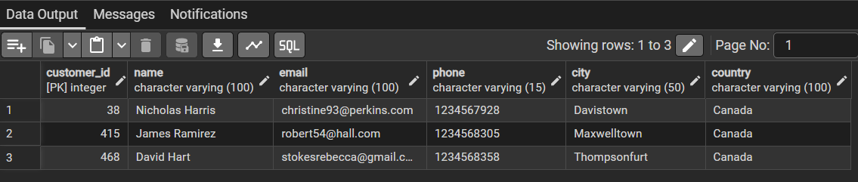
Q4. Show orders placed in November 2023 .

Answer:
SELECT * FROM Orders
WHERE Order_Date >= '2023-11-01'
AND Order_Date < '2023-12-01';
Output:

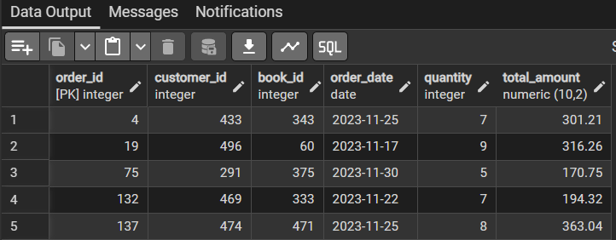

Q5. Retrieve the total stock of books available .

Answer:
SELECT SUM(Stock) AS Total_Stock
FROM Books;
Output:

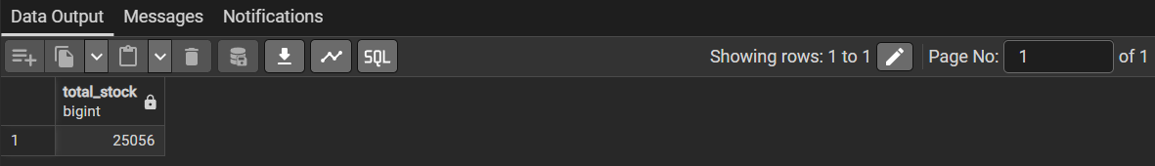

Q6. Find the most expensive book .

Answer:
SELECT * FROM Books
ORDER BY Price DESC
LIMIT 1;
Output:

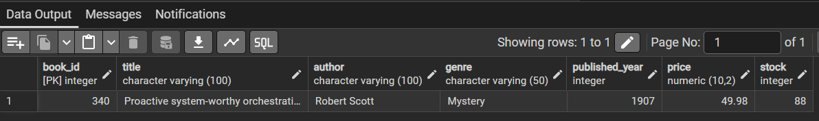
Q7. Show customers who ordered more than 1 quantity .

Answer:
SELECT c.Name AS Customer_Name, o.Quantity
FROM Customers c JOIN Orders o
ON c.Customer_ID = o.Customer_ID
WHERE o.Quantity > 1;
Output:

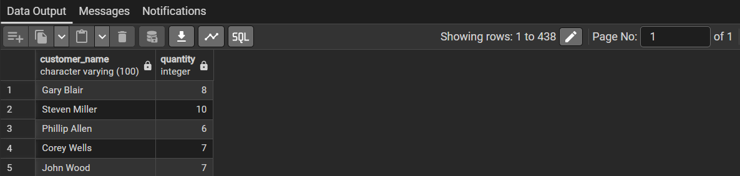

Q8. Retrieve orders where total amount exceeds 200 .

Answers:
SELECT * FROM Orders
WHERE Total_Amount > 200;
Output:

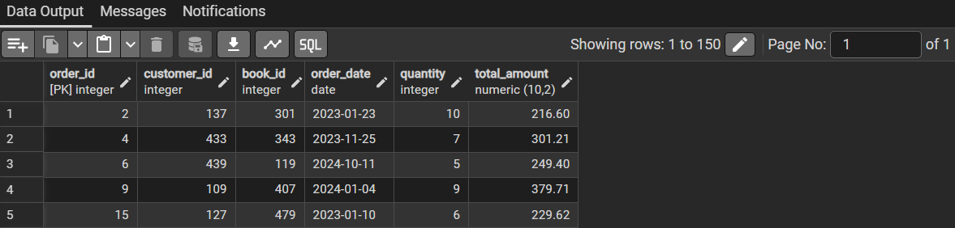

Q9. List all available book genres .

Answer:
SELECT DISTINCT Genre FROM Books;
Output:

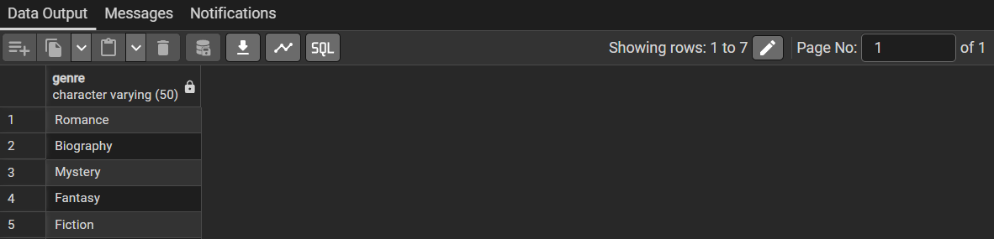
Q10. Find the book with the lowest stock .

Answer:
SELECT * FROM Books
ORDER BY Stock ASC
LIMIT 1;
Output:

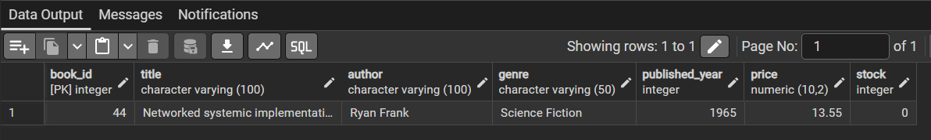

Q11. Calculate total revenue from all orders .

Answer:
SELECT SUM(Total_Amount) AS Total_Revenue
FROM Orders;
Output:

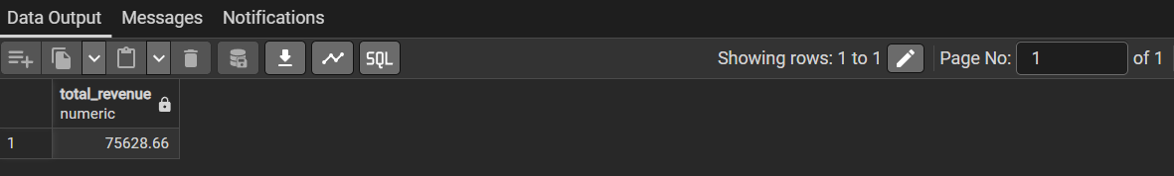

Advanced SQL Analysis

Q1. Total number of books sold per genre .

Answer:
SELECT b.Genre, SUM(o.Quantity) AS Total_Books_Sold
FROM Books b
JOIN Orders o
ON b.Book_ID = o.Book_ID
GROUP BY b.Genre;
Output:

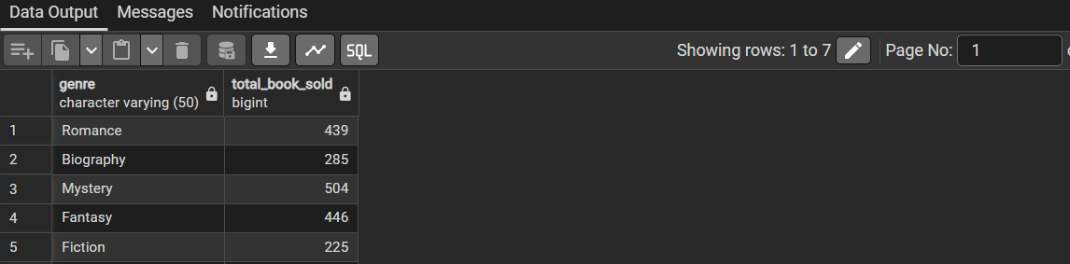
Q2. Average price of Fantasy genre books .

Answer:
SELECT AVG(Price) AS Avg_Price
FROM Books WHERE Genre = 'Fantasy';
Output:

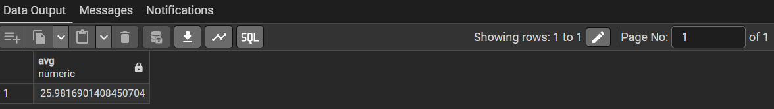

Q3. Customers with at least 2 orders .

Answer:
SELECT c.Customer_ID, c.Name,
COUNT(o.Order_Id) AS Total_Orders
FROM Customers c
JOIN Orders o ON c.Customer_ID = o.Customer_ID
GROUP BY c.Customer_ID, c.Name
HAVING COUNT(o.Order_Id) >= 2;
Output:

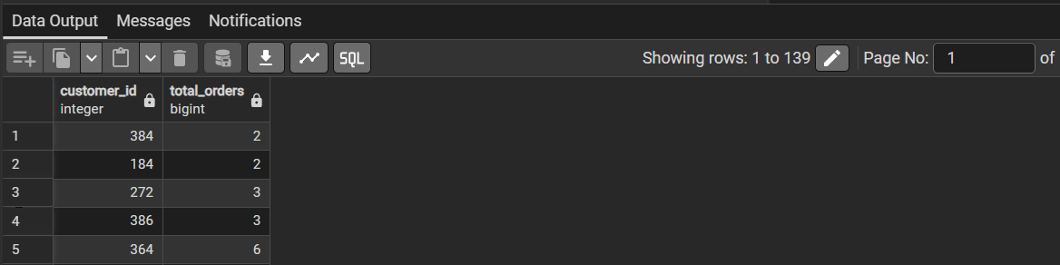

Q4. Most frequently ordered book .
Answer:
SELECT b.Title, COUNT(o.Order_Id) AS Order_Count
FROM Books b JOIN Orders o ON b.Book_ID = o.Book_ID
GROUP BY b.Title ORDER BY Order_Count DESC
LIMIT 1;
Output:

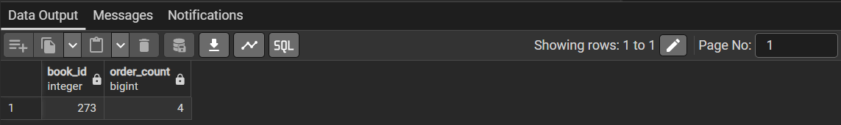

Q5. Remaining stock after fulfilling all orders .

Answer:
SELECT b.Book_ID,
b.Stock - COALESCE(SUM(o.Quantity), 0)
AS Remaining_Stock
FROM Books b
LEFT JOIN Orders o
ON b.Book_ID = o.Book_ID
GROUP BY b.Book_ID, b.Stock;
Output:

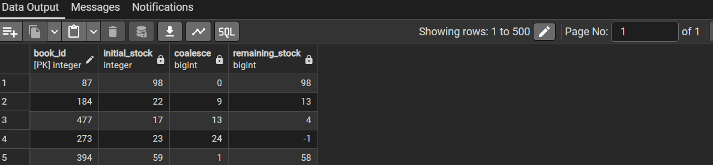

Q6. Find the customer who spent the most on orders .

Answer:
Select c.name,Sum(o.total_amount) As total_spent
from customers c
join orders o
on c.customer_id=o.customer_id
group by c.name
order by total_spent Desc;
Output:

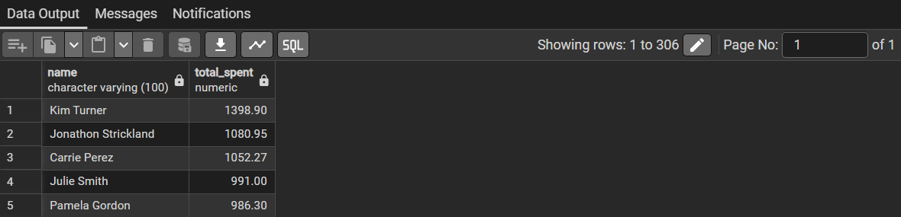

- Conclusion

This project demonstrates the practical use of SQL for data analysis, including database design, joins, aggregations, and business problem-solving. It reflects real-world scenarios such as sales analysis, customer behavior tracking, and inventory management.

Skills Used

- SQL (PostgreSQL)
- Joins & Subqueries
- Aggregation Functions
- Data Analysis
- Relational Database Design

